R&D Call 4
January 4, 2012
TASKS
54:28 Going back to making FLOS accessible…the situation for us in the second phase will be that I write out the TPOV. The TPOV then goes to Gary who does a quick edit, trying his best to make them readable. Starting next week, my hope is that Gary will edit the TPOV and send them to Michelle. Michelle will get one of her team to put them up on the wiki. We want people to go to them and add pieces so that they “live” through others.

57:07
In Phase 2, Gary takes the TPOV, does an edit, and sends it to MyPals. MyPals wiki it and also put it in autoresponder. Gary, once everyone comes back from their holiday vacation, I’d like you to get with Michelle and have this assigned so the process gets caught up. Once it’s caught up, let me know that people can now get the tips as FLOS101 from the opt-in.
58:15
I will re-write the squeeze page (now called the “See” Page). The See Page will transition to the Survey to try and pick up buying motivation. The Survey Page transitions to the Info Page that will have a video on it. Where do they go from there, Gary?

59:18
This is part of the design process I want you all to help me with. When we meet again on January the 16th we will decide the “target sell” for a person finding flawlessliving.info, .blog, .biz, or whatever we decide it’s going to be. What is it that people are going to want? What is the next step we are going to influence them to take?

1:04:20 We want to incorporate what we know about selection bias in allowing a user defined experience navigating FLOS. What are the possible experiences?
Gary will send a note with the url flawlessliving.info/dump. Before January 16th go to that url and put in any kind of program that we could monetize (psychically or materially), that could become part of the stream people find themselves in when they access FLOS.

1:19:53 Gary put up the concerns for the 2012 Forecast. This is why you need a survey page, folks. I thought the responses were really odd. Go to flawlessliving.info/forecast/concerns. Gary, whenever you do these concern pages, make sure you copy the exact question that we ask. The way people select from an inquiry and respond means as much to me as the content of their answer. The way they interpret the question and the way they answer it is a key to what people are seeing.

1:27:51 Gary, we need to set up the 24 charts on the Lanyep (?) page.

1:29:35 What happened to the script that Wayne built that caused the things to go over? Is it too hard to use on the fly? Do we have a template? Somebody built a script. I saw it once. It says that your email and your name gets passed through to the survey page and you don’t have to re-enter it. Do we have a template that’s usable?

Gary: I’ll check with Wayne to see about making it into a template. I was going to check with MyPals.

Mike: Okay. So we have to add a script into what? Whatever we’ve already added the script to becomes a template page. Couldn’t we just use that template every time on the opt-in page?

Gary: We have it set up for WordPress and I can see about making something for the other.

1:30:54 Between now and January 16 go to flawlessliving.info/dump and dump in there whatever you can think of in terms of what would make FLOS accessible. What kinds of programs should we have? Should we have a 24/7 FLOS Line? We could do that for $100 a month. We could have a “Coach on call” and the MyPals could take the call and contact the coach. Would people buy that? I want to see the array of ideas, not judge them. We are looking for ways to make FLOS accessible so we can monetize this.

ASKS

4:00 I encourage you, Gary, to continue experiment

11:45 Maybe we should put a note on The Change State page saying, “If you like this, <click here> to get more!”

34:06 One of the things I’ve been thinking about Bill creating a table with three columns: The Idea, What it Means in BS, The FLOS Subtle Difference.

34:53 I have wanted to make a comparison table like one that shows the difference between programs; a cheat sheet between BS and FLOS.
35:30
So maybe what I can do, Bill, is get the 101 points done, and make sure they adequately paint the picture of FLOS I have in my mind, or create the puzzle pieces for you to put together. Then create a table:
Topic | How Someone Would See This in Blank Slate | What This Means in FLOS
Inbornness

37:15
You’ve brought this up in a way that makes this more of a word picture, I can dump this into my subconscious and it will go to work on this.
37:38
I can have one of the MyPals post each row as a “callout” or a text table in the TPOV, and people would be able to see it right there. Instead of making this a multi-step process we’ll make it a multi-sequence process, keeping the pressure off me to get these done. Good idea. Thank you.
38:22
Bob, would you capture the tasks and would you also capture the ideas. The tasks are “what, by when,” actual assignments with a due date. The ideas are what we would call “asks” would be what I just talked about for our wish list.
39:00
There might be one or two of you that remember when I did B-Coach in 1999. I did a matrix table of all the coaching programs and how B-Coach treated particular items differentiating it from the other programs. That was really a good thing.
39:31
This will work because this is evergreen. All these tips are evergreen. No matter the operating system, an algorhythmic response will be triggered. If you’re in BS and you’re reading this you will say, “Oh, he’s not right about ‘inbornness.’ Inbornness has a lot less to do with my life and my behavior than the external environment.” Readers will form an algorhythm as a result of the TPOV which is still “the hook.”

44:26 I’ve thought about doing teaching videos with a white board.

48:15 Keeping a population in a bounded reality isn’t a bad solution if you choose the other bifurcated path. This is something I should have a call on. This is the radical Islamic answer to the new media. If our media leads people into unhappy cul-de-sacs, then would getting rid of the media lead people to be happier? We should have a conversation about it with some of my Muslim friends.

55:41 I am going to promote a collaboration model even though people probably won’t do it because their not used to doing this kind of stuff, they’re shy. I have to do it and model it even if people don’t do it. Write under an assumed name if you want to. Make up a character. Do an avatar.

1:00:42 That needs to be informed but not over-complexified, because that’s the easiest way to shoot ourselves in the foot. We need to formulate accessibility through ValueSync. This is something I’ve been wanting to do for years, but it takes so much effort. Maybe there’s a way to design a lot of the effort out.

1:02:29 One of the things we have to talk about in ValueSync (through the four movements: towards, away from, with, and against), and we’re looking at increasing density or looking at streaming. How do we create a stream of acts, non-acts, being, doing, having and becoming, such that the person is pulled along because of the expressed unconscious motives.
1:10:39 Manya: Is there a way to use our community as a laboratory based on our ValueSync? Let’s say we take people who self-identify with “Blue,” or “Green,” or “Orange,” or “Red,” and we say, “What are the applications in the programs that we would want?”

1:12:35 The difficulty is that people in the age of fractionalization will shun these four systems, saying, “It’s more complicated than that.” I’m suggesting we build bridges in the network of user defined that allow people to move from one stream to another.

1:15:25 As we think about all these pieces, the Blueprint that we’ve created for the seminar, reading the book, a four-session coaching seminar to guide them through the book, the Blueprint, the 12 Elements, the comparison of BS and FLOS perspectives on a specific problem. There will be a 13 week coaching cycle where a client would go through, get his or her sponsor, and work through the material. They can take ISIS. They can go through the assessment program. They could work in Type Dynamics. They can do Strengths Finder. There are at least 100 offshoots at this point in time. What I’m looking for is, “What kinds of things do you all see as possibilities if you were a FLOS Coach, a FLOS Guide, a FLOS Advisor, a FLOS neighbor, a FLOS community member, a FLOS church member? What kinds of tools, technologies, programs and services would you need? Drop over to the url that Gary is going to put up, and jot a couple of ideas down so we can discuss them on January 16th.
1:16:59 We have to design the applications and objects and the execution of them, and the execution is the hard part. The ideas that require additional funding will evolve over time. To generate funding there have to be some FLOSS Coaching clients. How do we attract people so we can monetize this system? It is essential to monetize to fund the gap. In lieu of having a FLOS application, the BS application will just have to run.
1:17:54 Bill: For me, it is, “How do I use the FLOS model to thrive in the new economy?”
Mike: That would be okay. It’s probably too big. We’d have to chunk that down. We would do it like this:
- “How do I use FLOS to make more money every day?”
- “How do I use FLOS to be happier each and every moment?”
- “How do I integrate FLOS to make my job better?”
- “How do I use FLOS to manage my people better?”
- “How do I use FLOS to make my payroll?”
- “How do I use FLOS to start a new business?”

1:19:27 The proactive 2% are going to find us on their own. The people who are going to need us are the ones who are going to say, “I need to solve a problem. What does FLOS do for _____?” What are the likely problems we’re going to need to solve?

TALKING POINTS
012
Welcome everybody to the Design Call.
016
I’m feeling pretty chipper today. I have learned to use my intuition which is 99.7% unconscious. I can dump my questions and problems into my subconscious mind, and wait (with anticipation and anxiety) for it to supply direction.
1:03
When an algorhythm comes out that solves a lot of issues, the path becomes clear, you have a greater sense of purpose, you can feel alignment as pieces fall into place.
1:30
I’ve been talking with Gary. My journey with Gary has been a journey also with my ego. If Gary doesn’t learn this stuff, it’s dead. I’m not going to invest this much of me again. (Laughs) I’ve been helping Gary find his way through the forest of internet marketing, FLOS, ValueSync, or whatever the program happens to be.
2:19
For eighteen months, Gary has taken the brunt of all of the issues. He’s held up (at least so far). The journey with Gary has mirrored the journey I’ve been on with myself. Can we ever close the gap between levels of capability that exist in the model itself? I think it’s starting to happen.
3:03
I notice the differences in what Gary writes and what I would have written. I have wondered if people respond to my work over time because of the vibrational level, frequencies, energy emitted from and syntax of my writing, rather than the reader responding to the content. That may be partly true, although Gary, I think we are getting some responses to what you are putting together.
4:00
I encourage you, Gary, to continue experimenting. It took me three to five years of writing these messages to develop a message that seemed coherent to me; something comfortable and purposeful, not necessarily “right.”
4:19
FLOS has multiple and concurrent design streams. Early on, I knew I could not do FLOS. I don’t want to be confined in or identified with one model.
4:51
FLOS, to some extent, has been the platform by which I have been able to design who “Mike” is and wants to be. At the same time FLOS has to become financially viable, or it doesn’t pay for the Gary’s, the Jackie’s, and everybody else.
5:22
We have to face the fact that we live in a BS world. “Success” is still defined by someone swiping their credit card or opening their wallet. Longevity, duplication over time, flattery are indications of a model “well done,” but in a Green (FS) system (peaking in the US and present elsewhere) there is “sacrifice of self to get NOW.”
6:30
The one thing that stands out for me when you look at Reiss’ “High Acceptance” in addition to self-doubting, empathy, radar, is “QUITTING.” There seems to be a mechanism that seems to be built into High Acceptance-like motivation that says, “If something’s not working, quit. Do something else.”
6:56
If the Green System that is willing to sacrifice self, doesn’t get NOW, it’s gone. You see this in politics, movements of money, our culture, excess labor (“unemployment”), etc. “If you don’t give me what I need, I’m going somewhere else.”
7:40
This is the main tenant of all internet marketing, selling one variation or another of the same thing for a decade or two. All of them sell the same thing! The internet isn’t full of networking because people can’t do the model on their own.
8:09
People continue to go to seminars, do coaching, and do change work for the same meta-reason – change doesn’t work.
8:33
The FLOS Operating System is not BS, but we have to recognize that people are running in BS. Our system has to combine BS and FLOS.
9:09
I’m suggesting that BS becomes an “application” not an operating system. BS run on FLOS should lead to greater results; we’ll be “towards” rather than “against” or “away from” BS consumers. “Successful” BS internet marketers don’t worry about the consumer’s needs getting met; marketers take the money and move on, or sell them the next program when the shoppers have forgotten they already had the first program.
9:45
I’ve been talking to Gary about the moral equivalent for FLOS. We don’t want to sell. We want to continue to influence, and that’s the part of BS we want to keep.
10:31
We need to be able to hang FLOS off of something that is accessible to more people. We know that FLOS has a very narrow target market right now: people who are in Beta and are looking for “flex-flow.”
11:10
To see the illustration Google change state indicator mike jay or click here. You’ll see this:
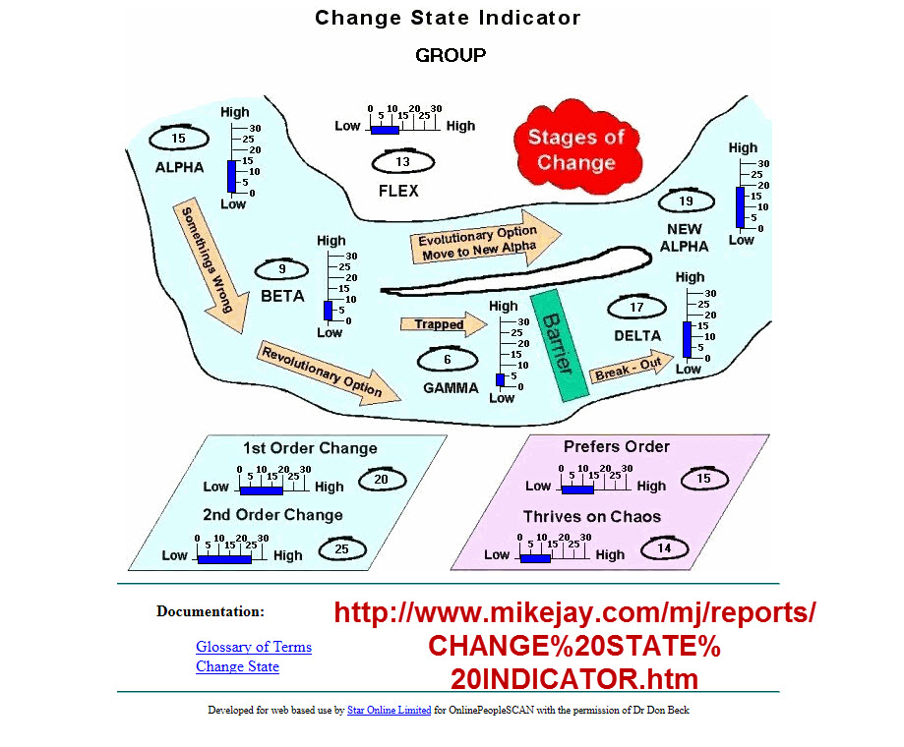
11:38
Gary, see how you get SEO (laugh)?
11:45
Maybe we should put a note on here saying, “If you like this, <click here> to get more!”
11:52
If you look at this Change State Indicator, the one clear contribution Clare Graves has made (and is totally underrated) is this model. This model helps us understand BS and change.
12:06
The Indicator shows movement from one state (“Alpha”) to another state (“New Alpha”). At “Beta” one is saying, “I’m doing what I’ve been doing, but it’s not working as well.” An internet marketer sending out campaign emails will notice that fewer people are responding.
12:36
Beta lasts until you figure out that something is wrong, you’re not just having a “bad day.” You’re faced with two choices at this point. Stick with it and “ride the dead horse,” or, you can ask, “Is there something else I could do, that would get at least the results I have gotten in the past?” The second choice is an evolutionary option in which you go through a “flex-flow.” That’s what FLOS is.
13:13
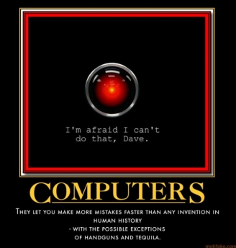
FLOS is like Hal, the computer in 2001 A Space Odyssey. It pulled out the beliefs, the memories with which it was programmed and put new ones in. That’s what FLOS allows you to do, even though it screws with your behavior for a while. FLOS allows you to reinterpret the “why” of behaviors.
13:47
Those who are meta-systematic enabled do not have the flexibility to go to FLOS. Early meta-systematic occurs in Work Level 3 in my view (not necessarily shared by all who study Elliott Jacques). My experience is that meta-systematic reasoning is introduced at the top of Work Level 3, if in fact you are Mode 5: Metasystic mode enabled by birth.
14:19
At some point in time you can take a perspective on a system of systems. That’s what meta-systematic reasoning is. Two per cent of the population might be meta-systematic enabled. Only two per cent of the population is above IQ 130. That’s two per cent of seven billion, or one hundred forty million people; quite a large number, and these people have a path like the salmon do – going back to where they were born; they find the same stream in which to congregate and evolve. You’ll be attracted to them if you are one of them, and repelled if you are not one of them. Those with meta-systematic reasoning will evolve.
15:22
There’s probably another 10 – 15 per cent of the population who can be scaffolded into that reasoning frame. That’s the future oriented target is for FLOS.
15:41
The rest of the people will probably ride the horse they’re on until someone lets them know their horse is dead, and offers them another one. That’s the people who are going to be trapped in “Gamma.” That’s where we’re going to go for “the problem,” but that’s not our target market. We can’t save those people in my view. They can only be saved by dying.
16:07
We have to design FLOS so it is accessible to the two per cent who are meta-systematic plus the ten to fifteen per cent who can be scaffolded to meta-systematic reasoning. Most of them may be in the stream in which we are already marketing.
16:27
They are out there asking questions. We have to frame the algorhythms to get them to understand that there’s a different answer over here they may want to look at. That’s part of the design process.
16:39
The second part of the process in understanding this Change State model, is the amount of energy that is going to be consumed in the breakout of the Gamma trap. This is the scary part of being alive right now. Many have predicted, with a good probability, that half the population will be gone within the next two decades. The reason for that is because of this Gamma situation. People will only be changed by “creative destruction.”
17:20
We are not going to appeal to everybody, but, can we appeal to those we can help, and those who can help scaffold that other group? Remember, the top fifteen per cent scaffolds the rest of the population. Two or three generations down the road, the ten or fifteen per cent who have gotten these new ways, FLOS being one of them, will then generate enough memetic code as a group to scaffold many others.
19:08
When we started this call I said I felt a sense of contentment because I think we’re really on to something. I’ve started writing the Teachable Points of View (TPOV). Gary and I have been talking about doing these since we started. My goal is to leave as a legacy for my grandchildren and great-grandchildren, videos of all of my “evergreen” TPOV that show how I got from where I was to where I will end.
19:45
This came together very quickly. It was pressure prompted, by the way, so for those of you with a preference for “Perception,” until you get to the point where you have enough pressure, you will not take productive action. Your “mother of invention” is sitting in a rocking chair on the front porch sewing on a quilt.
20:11
A lot of people are asking me, “Hey Mike! How do I get going?” I can tell you that you won’t get going until the pressure gets high enough. Most of the people we’re talking to will not do anything ahead of time. The reason is that they are pressure-prompted, and the pressure hasn’t gotten high enough.
21:06
In my case, pressure goes up, and I say there’s no question, we’re probably headed for a crash. The reason we’re going to crash is not because we have to. The reason we’re going to crash is because nobody thinks we can.
21:20
It’s typical for the Europeans to have eighty summit meetings and accomplish nothing. They’re repeating what they didn’t do before WWII. They are “actors” not “act-towards.”
21:54
Okay, so we’re going to crash. If we crash, what’s going to happen? Demand will go to shit. There will be no demand. Nobody will spend anything.
22:03
If you didn’t have a job on 9-11-2001 you went for a significant period of time without income. I went for eight months without income after 9-11! Try that. That’s what’s coming.
22:34
I don’t know how long it will last. It won’t last forever. Things will come back and be good again. My point is that you need to get off your duff and do something while we have this window. That’s how I’m thinking.
23:06
When this thing crashes I don’t want to have to be working. I don’t want to have to be chasing dollars. There’s not going to be any dollars out there. It’s going to cost you dollars to get dollars which is a negative situation. You might as well be sleeping, knitting, or reading. You don’t have much time for action.
23:22
If you have a job now you have a little time. If your only job comes from stirring up business, you won’t be able to stir anything up.
23:36
In my case, I thought, “I need to go into a burst.” This is not what I wanted to do this year. At the same time, my circumstances have begun to change a little bit, and the writing is on the wall for some things around me. That kind of pressure dumped into my subconscious spit out an algorhythm of, “write 101 tips on FLOS in 100 days.”
24:12
I talked to Gary and said, “I just need to start this and do it, because I can influence as I write, and you can write and do the marketing. I’ll stay busy and keep the phone lines going, responding to what people respond to in me, and then we’ll see if we can monetize this.” So, all of a sudden the trigger hit for me, and I said, “Yeah, it’s time to do these TPOV.”
24:48
I’m telling you all this because I’m telling you about your own design. Get of your asses and do something because you want to take advantage of this window of opportunity.
25:04
What you have to do may not be as big a deal as you think, but it might be what will send your energetic request into the universe. You can’t receive unless you ask.
25:19
That’s what I’m going to talk about in ValueSync. There are four directions, and so many people are moving in the “with” and “away from” directions, not the “toward” and “against” directions. You’ve got to change your design to go “towards” and “against.” I’m modeling what I’m suggesting that you have to do to turn up the pressure.
25:46
You’ve got four dials. These four dials are “towards,” “against,” “with,” and “away from.” Normally you wake up and your dial is set on a particular level of intensity from which you naturally operate. You’ve got to take a “snapshot” of that. That’s your normal operating day.
26:04
Then the second thing you have to do is go take a look at the conditions. The conditions, and the requirements of the conditions, say, “Hey! If you don’t ask, you don’t receive.” You can’t wait, because waiting may put you in a position in which there is less to receive even if you do ask.
26:29
There’s another set of dials called the “requirements.” You’ve got “happiness” on one side and “success” on the other side. You’re looking over at that success side and saying, “Wow. This looks a lot different than the side that’s normal ‘happiness’ for me. How can I change what needs to be done? My normal dials are set on the levels in my snapshot, what will I do to increase the levels of ‘towards’ and ‘against’ and turn down the levels of ‘with’ and ‘away from’?” You’ll need IMULL (importance, motivation, urgency, leverage, and low hanging fruit) to sustain the new levels.
27:12
Why am I doing this? I’m the only one who can do the content. Looking at 100 days of doing anything is the most boring thing I can think of in the world. I go back to my “2 and 98” model. I need to write about that on the TPOV. Gary, add that to the “ideas” page /dump.
28:16
There are 1,440 minutes in every day. I fooled myself by telling myself, “If I go do what I don’t want to do for 2% of my day, I’ll ‘own’ the 98% I have left to do what I do want.” That’s the “deal” I made with the “devil.” (See Charlie Daniels, Devil Went Down to Georgia Lyrics).
28:53
I don’t want to do the same thing every day, and I don’t want to wake up with an alarm or a to-do list. Two per cent of 1,440 is about 30 minutes. You trade 30 minutes to do things that you can do but aren’t motivated to do and don’t want to do, and get back the twenty three and a half hours of your day. Based on your capability you may have to adjust it to 5/95 or 20/80.
29:38
I’m lucky because I can do almost anything that I want to do, but, of course, I know that I won’t, which is the difference between BS and FLOS.
30:10
The meta-idea is if you’re going to do something, make it as easy as you can to do it. If you find something that’s making it hard for you to do the essence of what you need to do, don’t do it. When I started writing the TPOV I had to decide not to go for a polished piece, but complete a full first draft, because the essential goal was to create the “backbone” allowing greater accessibility to FLOS.
30:52
John Agno is a pretty smart guy, especially when it comes to being successful. On the Design Call John said, “No matter what you do, you have to make things accessible.” The biggest thing that we don’t have in FLOS is a glossary.
31:10
We have a glossary that was started six years ago, and we are working on that in the wiki, but it’s not very good. If I define 101 key points “enough,” I’ll have the essence of FLOS. That’s good enough to start.
31:53
I have found that this task is enjoyable and I’m actually starting to look forward to writing because of all the new cool things that I think about that I do all the time, like 2/98. Now I’m actually one or two days ahead, and some of the pressure is falling away. I admit that I’m only at 7 with 94 to go, but it feels really good at this point, and I feel that when I get done, I will have done something that will last forever.
32:36
The design came to me when Gary and I had that conversation. I want to get your feedback and then I want to talk to you about what Gary and I are going to do about running this out.
33:40
Bill: It would be helpful to have what the point of view means in BS, and then what the point means in FLOS.
34:06
One of the things I’ve been thinking about Bill is to create a table with three columns: The Idea, What it Means in BS, The FLOS Subtle Difference. I will think about how to do what you just said and see if I can weave that into the model that I have. The more pieces of “have to” I add, the more “viscous” it becomes in terms of completing this.
34:53
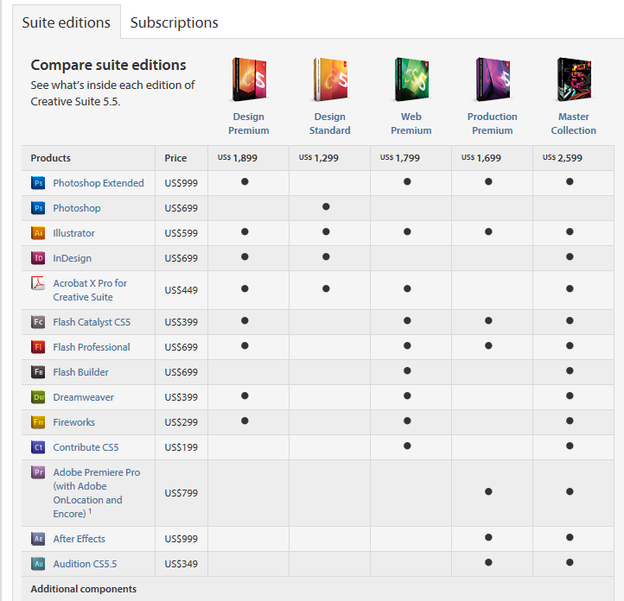
When is the last time any of you wrote 101 of anything? Have you ever tried that? Have you ever written a book? That’s the same thing I’m doing right now. That’s a great idea. I have wanted to make a comparison table like one that shows the difference between programs; a cheat sheet between BS and FLOS.
35:30
So maybe what I can do, Bill, is get the 101 points done, and make sure they adequately paint the picture of FLOS I have in my mind, or create the puzzle pieces for you to put together. Then create a table:
Topic | How Someone Would See This in Blank Slate | What This Means in FLOS
Inbornness

37:15
You’ve brought this up in a way that makes this more of a word picture, I can dump this into my subconscious and it will go to work on this.
37:38
I can have one of the MyPals post each row as a “callout” or a text table in the TPOV, and people would be able to see it right there. Instead of making this a multi-step process we’ll make it a multi-sequence process, keeping the pressure off me to get these done. Good idea. Thank you.
38:22
Bob, would you capture the tasks and would you also capture the ideas. The tasks are “what, by when,” actual assignments with a due date. The ideas are what we would call “asks” would be what I just talked about for our wish list.
39:00
There might be one or two of you that remember when I did B-Coach in 1999. I did a matrix table of all the coaching programs and how B-Coach treated particular items differentiating it from the other programs. That was really a good thing.
39:31
This will work because this is evergreen. All these tips are evergreen. No matter the operating system, an algorhythmic response will be triggered. If you’re in BS and you’re reading this you will say, “Oh, he’s not right about ‘inbornness.’ Inbornness has a lot less to do with my life and my behavior than the external environment.” Readers will form an algorhythm as a result of the TPOV which is still “the hook.”
40:09
To attract attention over time, you have to make it evergreen, which means it has to appeal to every application and operating system. The other requirement is that it has to have a hook, that is, it generates an algorhythmic response from the viewer’s memetic system, even if it’s an immune response. That’s why some of my websites, even though they haven’t been updated in ten years, are still generating subscriptions. That’s what we’re teaching in Happeneur, and what I’m modeling here.
40:54
Anyone can do what I’m doing. You will do it differently. You might hire someone to do it. If you don’t write, or you don’t have the content, you can go right to Elance and you can get someone to write, research, assimilate, or clip this for you. It doesn’t have to be perfect to attract someone to it.
41:41
I guarantee you that one thing that would get you traffic right now is if you had the 101 Best Ideas of the Last 100 Years. That’s an idea I had right now as I was thinking about how to tell you about generating traffic. You could write that, put out a report, put the 101 Ideas in an opt-in. You could have someone from Elance research it for you. You wouldn’t have to do anything. It would cost you about $500.
42:21
Why would you do that? What would I do FLOS? Why would I do these 101 TPOV’s? To make the result accessible, and it will only be accessible if they opt-in, email us, or contact us. So we have to have a hook.
42:43
Manya: What is the hook in the 101TPOV?
Mike: I think the hook is the title: Blank Slate, Inbornness, and Corporate. People in our target market, that 2-15% are interested in those things. “Inbornness” is not even in a dictionary yet. “Corporate” really means what? “Blank Slate,” what is that; I’ve heard of that.
43:18
Manya: So it’s being curious?
Mike: Not necessarily. We could be offering something, “Just in case,” or, “Just in time.” If you’re searching on the web for ideas to solve a problem, and our topic comes up as an algorhythmic response, that’s a hook.
43:45
You’re also into Phase 2. We have not yet given the TPOV the hook that they really need. People respond well to video. Video’s that go “viral” make a pretty good hook. There is a problem capturing the viewer. People look at them and leave.
44:26
I’ve thought about doing teaching videos with a white board. These TPOV’s are multi-faceted and multi-layered. What I teach you about “Inbornness” has nothing to do with inbornness, it has to do with a lot of other things. Each TPOV is multi-faceted.
45:20
Once we have the videos, Manya, we will have the written, the audio, the video, and the context. I think you can hook people with context, which is why I mentioned “just in time” and “just in case.” We can put pay-per-click ads up on Google and everything else for very little money that provides a context for someone searching a connected topic. That’s a couple of years of work, but the idea is an example of how we’re going to hook people.
45:58
Somebody will read something about “Blank Slate,” or “Corporate,” and you’ll notice that I’m putting some of the ideas in the TPOV’s in bold. Ideas in bold are hyperlinks to other ideas, so studying FLOS can be accomplished by “chasing” the hyperlinks. Your interests will create your path through the material. Each idea links to all the other ideas. This mirrors the evolution of education. You create your own educational path by noticing the words that attract you and therefore something about your value system.
46:45
Spiral Dynamics as reflected by Don Beck and Chris Cowan doesn’t reflect a lot of what Clare Graves proved. Graves’ position is that education will become “user defined” rather than “mass defined.” That’s the thing I am trying to do with the K-12 program in FLOS.
47:24
If I go to a family that has no TV, internet, or computer, would I just be infecting them with BS if I provided internet, etc. to them? Then I have to look at, “If these people are going to be poor, the children are going to grow up into a world where they are always chasing; the world of media. If I put media in there, the children are going to start learning. Will they learn the right things? Not really. But they will learn. The question becomes, do you help someone learn even if the things they learn aren’t the right things, or do you prevent them from learning (a la radical Islam), and keep them in a mold that has a bounded reality?
48:15
Keeping a population in a bounded reality isn’t a bad solution if you choose the other bifurcated path. This is something I should have a call on. The is the radical Islamic answer to the new media. If our media leads people into unhappy cul-de-sacs, then would getting rid of the media lead people to be happier? We should have a conversation about it with some of my Muslim friends.
49:23
Closing my thought about that family with no TV, if I introduce media into the household, the children begin to learn differently. I don’t know if that’s a good thing or a bad thing yet. I have already introduced families to media and wonder about the moral consequences of my intervention.
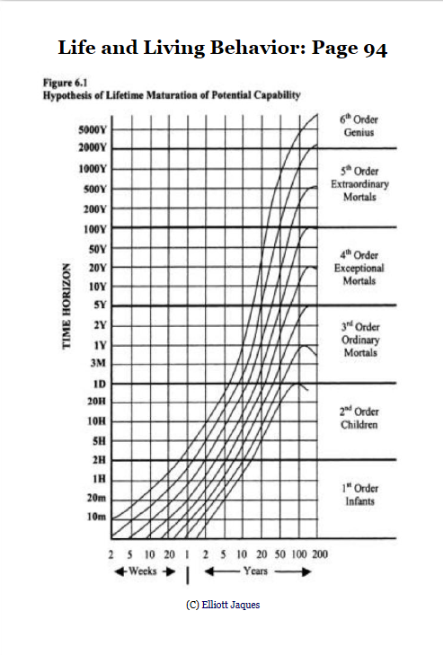
49:51

I have crossed paths with a couple of really bright people, and Herb and I have been talking about it. Go to flawlessliving.info/trajectory. This is a chart that Jacques did when he was in his 70’s and published in The Life and Behavior of Living Organisms: A General Theory (2002). I actually got this chart from Google.

50:38
What you see here is the result of Jacques’ research on human capability. It shows the languaging capability of people. Every once and a while I run across someone I think could have very high potential. You can’t know when people are young.
51:17
I met a 14 year old girl who Herb and I think is “sitting on” at least 3rd Order Cumulative. On the chart that’s the second line under “3rd Order Ordinary Mortals;” that’s not in her mother tongue. At 14, her line is between the last two curves to the left. That curve goes to “genius.”
51:54
I don’t know if Jacques’ model or my assessment is reliable enough, but it could be that this person is genius. Neither the girl nor the family has a cell phone or TV. She does have access to a computer, and at 14, her response was, “If I don’t know something, I Google it.” This is a person with very limited education.
52:29
What will be the life consequences if I give this person an iPad? This would be an intervention. This person is going to discover because this person is curious. Most likely, fast curve, fast learners are going to be curious by default. Learning is nothing more than iteration speed. So, Manya, do we find a way to give this potential “genius” an iPad?
53:20
Manya: I’d say, “Yes.”
Mike: That’s the thing. You know she is going to learn. Do you catalyze what’s there, and do you make her the gift of something she could receive no other way? This particular person has nine little brothers, four in diapers. She is the only girl. Her father is a dress-maker. Her mother scavenges. This girl doesn’t know if she will be able to complete school, but she is already at grade 2. She’s attending school two-thirds of the time and her grade average is 85%.
54:28
Going back to making FLOS accessible…the situation for us in the second phase will be that I write out the TPOV. The TPOV then goes to Gary who does a quick edit, trying his best to make them readable. Starting next week, my hope is that Gary will edit the TPOV and send them to Michelle. Michelle will get one of her team to put them up on the wiki. We want people to go to them and add pieces so that they “live” through others.
55:41
I sent out a piece on collaboration, and it’s very easy to see why we don’t collaborate, and why FLOS will fail. FLOS will have to be scaffolded in order to succeed. The wiki is a collaborative platform where anyone can go in and make changes and additions. I am going to promote a collaboration model even though people probably won’t do it because their not used to doing this kind of stuff, they’re shy. I have to do it and model it even if people don’t do it. Write under an assumed name if you want to. Make up a character. Do an avatar.
56:48
That’s why Second Life is so popular.
57:07
In Phase 2, Gary takes the TPOV, does an edit, and sends it to MyPals. MyPals wiki it and also put it in autoresponder. Gary, once everyone comes back from their holiday vacation, I’d like you to get with Michelle and have this assigned so the process gets caught up. Once it’s caught up, let me know that people can now get the tips as FLOS101 from the opt-in.
58:15
I will re-write the squeeze page (now called the “See” Page). The See Page will transition to the Survey to try and pick up buying motivation. The Survey Page transitions to the Info Page that will have a video on it. Where do they go from there, Gary? We don’t have a sales funnel in place.
58:54
What is it that we want to do? Do we want to send them to the Flawless Blog at that point? Do we want to get them to buy the book? Do we want them to buy the book and them upsell something, we know that we want them to have a chance to buy the assessment package for sure. What else? The Flawless Coaching FastStart?
59:18
This is part of the design process I want you all to help me with. When we meet again on January the 16th we will decide the “target sell” for a person finding flawlessliving.info, .blog, .biz, or whatever we decide it’s going to be. What is it that people are going to want? What is the next step we are going to influence them to take?
1:00:42
That needs to be informed but not over-complexified, because that’s the easiest way to shoot ourselves in the foot. We need to formulate accessibility through ValueSync. This is something I’ve been wanting to do for years, but it takes so much effort. Maybe there’s a way to design a lot of the effort out.
1:01:07
We know that be, do, have, and become are going to become more pure in terms of the selection because of regression. When we regress we move out of “want to” to “have to,” and have to is linked to what it is we feel the world is for us. If comfort for us is action, then you’re going to want to access something that talks about taking action.
1:01:45
Those who regress past “have to” into “need to” may be intrigued for a period of time because of selection bias in their own motivational system because of urgency and conditions, to actually select action. But if we have an action stream, then what is the developmental path for those people in that stream? That’s the easiest stream for me to do.
1:02:12
The next stream is the “Being” stream, and that’s the Green stream. Many will regress back into the shadow of Red, and they will feel like they have to go into action too, although it will be an indirect action. The “hype” of direct action will turn this group off.
1:02:29
One of the things we have to talk about in ValueSync (through the four movements: towards, away from, with, and against), and we’re looking at increasing density or looking at streaming. How do we create a stream of acts, non-acts, being, doing, having and becoming, such that the person is pulled along because of the expressed unconscious motives.
1:03:15
Graves proved that specific words show up to the viewer based on his/her values system. It’s like in the move A Beautiful Mind (go to http://youtu.be/Vzpu-P2eRuI) when specific numbers “light up” in Dr. Nash’s perception. That’s called “selection bias,” and all of us have this bias in our brains. We’re inborn with it. Graves figured out how to correlate to specific value streams the time intervals between showing a person certain words and their recognition response.
1:04:20
We want to incorporate what we know about selection bias in allowing a user defined experience navigating FLOS. What are the possible experiences?
Gary will send a note with the url flawlessliving.info/dump. Before January 16th go to that url and put in any kind of program that we could monetize (psychically or materially), that could become part of the stream people find themselves in when they access FLOS.
1:07:24
In summary, there’s a big design point here. Going back to some of the threads I’ve talked about all the way through the process, including the K-12 education process, and the intervention in the family with no media, we need to understand that the design needs to be user defined. Let’s say we’re going to educate people, what would be the easiest way in FLOS to educate people? Would it be to control how they are educated or would it be to give them the educational options from which they self-select and we provide scaffolding and support for them when they got stuck?
1:08:19
Let’s say this 14 year old has an iPad with Excel Note on it as an application, could she not then do her family’s budget as a requirement for education? In doing the budget she learns how to use Excel. She learns how to do a spreadsheet. She learns to do arithmetic and use formulas. If we gave children practical life problems and said, “Here’s where you start, and here are all the resources that you can use. If you get stuck come to us.”
1:09:06
The kids who are not geniuses will respond, “What did you just say?” Then we’ll get more specific about the defined processes, “Open this. Do this. Do this.” Other children will say, “Oh, I already know how to do steps 1 through 4. Do I have to wait for you to tell us and show us how to do it?
1:09:32
In education today, we’re focused on the “average” student. The slow students are lost, and the fast students are bored.
1:09:43
The same principle applies in adult learning. We have to fashion the experience that allows the person to navigate through the process on his or her own. We have to design the objects from which users select on their algorhythmic journey.
1:10:39
Manya: Is there a way to use our community as a laboratory based on our ValueSync? Let’s say we take people who self-identify with “Blue,” or “Green,” or “Orange,” or “Red,” and we say, “What are the applications in the programs that we would want?”
Mike: That’s what I’m hoping will happen with you that are here, and we will expand it so others can dump their ideas into the system as they join us.
Manya: I’m wondering about systematizing it a little bit more so that we would have a cluster of each value stream.
Mike: You’re taking a page right out of Graves. That’s exactly what he said.
1:12:35
The difficulty is that people in the age of fractionalization will shun these four systems, saying, “It’s more complicated than that.” I’m suggesting we build bridges in the network of user defined that allow people to move from one stream to another.
1:12:51
For instance, let’s say someone wanted action, they could choose “hands-on” action or “communal” action. The person knows action is needed because he or she is regressed, repressed, and pressure prompted, but at the same time, the person won’t work there and really needs help somewhere else so there is another window to move through.
1:13:17
If you take 4 and multiply it times 4, you get 16 paths. We can begin to weave in the preferences, motives, and learning styles. I’m suggesting that we all give this some thought. We can’t over complexify this. What I just suggested would cost over a million dollars. The only people even starting to do this are very sophisticated and have lots of funding. We have more psychic funding than anything, so we’ll have to be careful and keep it simple. I think we can “fake it until we make it” in terms of the initial offerings that we’ll roll out in March or April, 2012.
1:14:11
All of you are already in the program. You are going to help design and then go through the experience of Flawless Coaching. We need to collaborate for this to be a global piece. We don’t have the program yet, but I’m asking you to tell me what it is that you would want the program to be as a Flawless Guide mentoring a tribe of Flawless Coaches or as a Flawless Coach helping clients to navigate through their parts of the system.
1:15:25
As we think about all these pieces, the Blueprint that we’ve created for the seminar, reading the book, a four-session coaching seminar to guide them through the book, the Blueprint, the 12 Elements, the comparison of BS and FLOS perspectives on a specific problem. There will be a 13 week coaching cycle where a client would go through, get his or her sponsor, and work through the material. They can take ISIS. They can go through the assessment program. They could work in Type Dynamics. They can do Strengths Finder. There are at least 100 offshoots at this point in time. What I’m looking for is, “What kinds of things do you all see as possibilities if you were a FLOS Coach, a FLOS Guide, a FLOS Advisor, a FLOS neighbor, a FLOS community member, a FLOS church member? What kinds of tools, technologies, programs and services would you need? Drop over to the url that Gary is going to put up, and jot a couple of ideas down so we can discuss them on January 16th.
1:16:59
We have to design the applications and objects and the execution of them, and the execution is the hard part. The ideas that require additional funding will evolve over time. To generate funding there has to be some FLOSS Coaching clients. How do we attract people so we can monetize this system? It is essential to monetize to fund the gap. In lieu of having a FLOS application, the BS application will just have to run.
1:17:54
Bill: For me, it is, “How do I use the FLOS model to thrive in the new economy?”
Mike: That would be okay. It’s probably too big. We’d have to chunk that down. We would do it like this:
- “How do I use FLOS to make more money every day?”
- “How do I use FLOS to be happier each and every moment?”
- “How do I integrate FLOS to make my job better?”
- “How do I use FLOS to manage my people better?”
- “How do I use FLOS to make my payroll?”
- “How do I use FLOS to start a new business?”

1:19:00
Remember what’s happening right now Bill, in response to what you just said, I’m giving you an algorhythm. You’re going to have to chunk it down to the daily needs. For now, all things in this new economy are going to have to be chunked down to the 4F’s. That’s all you’ve got to work with.

1:19:27
The proactive 2% are going to find us on their own. The people who are going to need us are the ones who are going to say, “I need to solve a problem. What does FLOS do for _____?” What are the likely problems we’re going to need to solve?

1:19:53
Gary put up the concerns for the 2012 Forecast. This is why you need a survey page, folks. I thought the responses were really odd. Go to flawlessliving.info/forecast/concerns. Gary, whenever you do these concern pages, make sure you copy the exact question that we ask. The way people select from an inquiry and respond means as much to me as the content of their answer. The way they interpret the question and the way they answer it is a key to what people are seeing.

1:21:35
These aren’t concerns. Did we not make the question clear? Did people just put something in the box without reading the question?

1:22:15
The reason you want to use a survey page is to understand what’s going on in the minds of the people who are on your pages. I see in the items listed here, a broad naiveté, very narrow thinking, “wrong” thinking.

1:22:15
I also see, “Free from financial debts.” There’s a buying motive! “How does FLOS help free me from financial debt?” “How does FLOS grow your neighborhood?” “How does FLOS grow your community?” When we’re looking for problems seeking solutions, Bill, we can use options like these.

1:23:34
When I look at all these concerns, I take a big sigh of relief. Does anybody know why? Even though there are lots of concerns there, and most of them are generally tilted in the direction of life being different than it has been (that’s your Beta), but there is not a sense of despair or urgency or survival level need. That means the “window” is still open. There’s no belief that things are or going to get that bad.
1:24:26
We can monitor sentiment from concerns and comments. This is telling me that the one hundred and ten people who answered this were not clearly concerned about their money running out next month. There’s no time-bound sense of urgency. These are surface concerns. What that tells me is that these people do not feel the pressure of the onset of a depression. People are continuing to spend.

1:25:55
This isn’t so good for the people responding because it means they aren’t taking actions enough now to make sure that if and when this paradigm shift happens. If you understand Plank Theory, you’ll know that this will happen almost overnight, not like the Bear Sterns/Lehman situation that took months and months to roll out.

1:26:15
We’ll wake up and start to see something happen, and then chaos will explode as everyone gets scared and runs for the exits. It will take only a few hours or a few days for everything to go to hell. There will be no lead time. You’re done. The lead time is now. If you’re going to do anything, do it now. When we get the signal, it will be too late to act.

1:26:54
Jim Rogers said the other day, “We had something in 2000, and it happened to us. We had something in 2002. We had something in 2006. We had something in 2008. And now, the next one we have will be even worse. And the next one will be worse.”

1:27:10
Why? Because we’re still not solving the problem. The slack and the buffers are being taken up, and I’m saying this to myself as much as anybody. I’m pressure prompted too. When an event happens and there’s no slack, all you can have is an immediate knee-jerk response.

1:27:32
The people with money are already afraid. People are not buying commercial real estate. People are not investing.

1:27:51
Gary, we need to set up the 24 charts on the Lanyep (?) page.

1:29:35
What happened to the script that Wayne built that caused the things to go over? Is it too hard to use on the fly? Do we have a template? Somebody built a script. I saw it once. It says that your email and your name gets passed through to the survey page and you don’t have to re-enter it. Do we have a template that’s usable?

Gary: I’ll check with Wayne to see about making it into a template. I was going to check with MyPals.

Mike: Okay. So we have to add a script into what? Whatever we’ve already added the script to becomes a template page. Couldn’t we just use that template every time on the opt-in page?

Gary: We have it set up for WordPress and I can see about making something for the other.

1:30:54
Between now and January 16 go to flawlessliving.info/dump and dump in there whatever you can think of in terms of what would make FLOS accessible. What kinds of programs should we have? Should we have a 24/7 FLOS Line? We could do that for $100 a month. We could have a “Coach on call” and the MyPals could take the call and contact the coach. Would people buy that? I want to see the array of ideas, not judge them. We are looking for ways to make FLOS accessible so we can monetize this.

1:31:50
I wish I could do my work and not worry about whether I made any money or not. That’s what I was pointing towards in 2012. Conditions have changed such that you can’t just do that unless you have a big resource pile. Since most people with resource piles aren’t going to be on our calls, and aren’t worried about FLOS because they’re too busy doing whatever they want to do.

1:32:37
If this were a full FLOS system, each of us would wake up every day focused on doing what it is that we do best and effortlessly. There is a group who would find a way to contribute and be part of the process. We have to understand that as an ideal. We’re still in the BS world that says, “If you’re not ‘successful’ you can’t have or do things.” We all still have to worry about the 4F’s, especially as independent professionals.

1:34:14
Independents are the first ones to go in this next crash. They will be hit the hardest because there will be so little discretionary income. That’s why it’s a good idea to get a job, a contract, a retainer, or something from somebody who will still be standing after the tsunami hits. That’s what will give people the most time. The people who will fall off the cliff are the people who thought they had work, but don’t have it. They won’t be able to go out next week and get the next new client. The next new client won’t be out there.

1:34:52
It takes the economy time to digest the movement that has already begun. Many people are experiencing fewer available clients because we have negative demand. No one will be left a year from now unless you have something you can convert into currency.

1:35:30
We have the next three months to figure out what will keep you here, what will keep us together, what will transform flowing energy and information into the currency that each of us wants. We have to be very careful that this is seen as a collective effort to do what I’m suggesting that you should be doing in your churches, neighborhoods, and communities. Get real serious about what it is that you will use to attract a client or customer, how will you serve that client or customer, and what are they going to be able to exchange for what you give them.

1:36:27
There’s no magic bullet. These are clear minimum requirements for success. The Flawless Coach has to be able to add value and make a difference. They have to provide or play a key role in creating a solution that increases the 4F’s in some form.

1:37:00
What is keeping the financial experts up at night is the conclusion that people will not respond well to the loss of discretionary income. 90% of our economy is service related so when services are no longer consumed, service workers stop getting paid resulting in an asymmetrical cascade that will affect all of us. The problem with a depression is that nobody escapes. The questions are, “where am I going to spend it,” and “what will I do with my time?”

1:37:49
The longer the depression and/or the more disruptive the depression the greater the likelihood of social unrest. We could lose transport services so food becomes scarce. There could be war in the Middle East disrupting the flow of oil. How long could you pay $10 for a gallon of gas?

1:38:50
As soon as we really scare people we have issues. We have to translate this into, “how do we generate currency?” As people take what we offer and translate that into something useful, that’s okay. We have to think about how we’re going to make more money when money is going to be hard to find. This will be the same problem church will face without tithes and communities will face without tax revenue.

1:40:00
The problem is that even with warning there won’t be anything you can do to remedy the scarcity. That’s what scares me the most, and that’s why we have to do something about it now. If we’re spending what we have left on options with no pay off we will be confronted with survival very very fast. This is a very difficult situation that we’re going into. We intuitively expect the ride down to look like the ride up, but that won’t be the case. Spending won’t be the answer. You have to be in a position to get a return on your investment or be saving, and that means you need income.

1:41:32
I believe that when we believe we can’t, the worse it gets.

1:41:48
The good news is that if I’m wrong about what is going to unfold, there is no downside, we will all be better off. It’s what we should be doing as a good business person. The pressure is on us to get it right the first time.

1:42:10
Thanks everybody.

